Index

Abstract (1 page)

1. Introduction (about 15-20 pages)

1.1. ????
1.2. ????
2. Aim of the project (1 page)

3. Material & Methods (about 15-25 pages)
3.1. ????
3.2. ????
4. Experimental Results & Discussion (about 20-30 pages)
4.1. ???? ??
4.2. ????
4.?. Conclusions and future perspectives

5. Appendices
6. Bibliography
Format code:
- Calibri 11: literal copy and paste from papers
- Times new roman 12: paraphrased
- Red: may be deleted
- Blue: notes

INTRODUCTION
- Epigenome/methylome definition (yellow)
The epigenome is the group of chemical adducts which may be attached to DNA as modifications of nucleotides or to protein scaffolds of the genome in a non-mutational way and modulate genomic behaviours (Chapin et al. 2022).
While epigenetic regulations have predominantly been studied in eukaryotes, where they play a role in cell differentiation and disease development, there is growing evidence supporting the existence of epigenetic regulation in prokaryotes. Among these regulatory mechanisms in prokaryotes DNA methylation is the most common instance. The methylome is the group of bases, from a genome, modified by the addition of a methyl group to an Adenine or a Cytosine by enzymes called DNA-methyltransferases (MTases). There are three types of MTases depending on the modification they catalyse: N6-methyl-adenine (m6A), C5-methyl-cytosine (m5C) or N4-methyl-cytosine (m4C). Although the three types are described in both archaea and bacteria, the m4C modification is not reported in eukaryotes. The DNA methylation profile is species-specific or strain-specific (Payelleville and Brillard 2021).
- Classification of MTases
Bacterial DNA methyltransferases (MTases) are commonly functionally associated to a restriction endonuclease (REase) building the restriction-modification systems (RM), which are known to protect the bacterial cell from foreign DNA. (Payelleville and Brillard, 2021). However, it is suggested that restriction enzymes may have initially evolved to prevent the loss of DNA methyltransferases by post-segregational killing by selfish RM rather than solely targeting foreign DNA. The purpose of retention of MTases in genomes may be also due to their involvement in epigenetic regulation or their impact on gene flux and host genome composition (Sánchez-Romero and Casadesús, 2020; Oliveira and Fang, 2021).
Orphan DNA methyltransferases are those not coupled to a restriction domain and are found in many bacterial and archaeal genomes (Sánchez-Romero and Casadesús, 2020). The same MTase domain rarely appear as both, part of complete RM systems or orphans, indicating the loss of the cognate restriction enzyme or acquisition through horizontal gene transfer (Oliveira and Fang, 2021). Bacterial MTases have both de novo and maintenance activities (Sánchez-Romero and Casadesús 2020).
The classical types of RM systems, classified in Type I, Type II, and Type III, differ in structure, sequence recognition, cleavage position, and cofactor requirements. Additionally, Type IV "restriction systems" consist of only restriction enzymes that cleave modified recognition sites (Oliveira and Fang 2021). Regarding type II, the restriction and modification domains are, in most cases, able to operate separately and independently from each other (Roberts and Macelis n.d.).
- MTases in Escherichia coli K-12 substr. MG1655
Escherichia coli K-12 substr. MG1655 possesses several DNA methylation systems. It has one type I RM system called EcoKI, which targets the recognition sequence AACN6GTGC and performs m6A modification. Additionally, it harbors three different type IV systems, EcoKMcrA, EcoKMcrBC, and EcoKMrr, which require methylation for their function (Roer, Aarestrup, and Hasman, 2015).
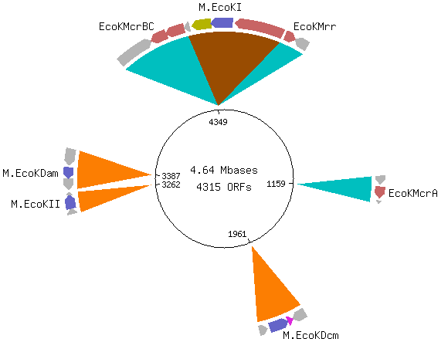
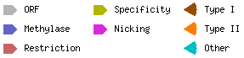
This E. coli strain also contains three type II systems consisting of orphan MTases, namely Dcm, Dam, and MEcoKII. These MTases recognize the sites CCWGG, GATC, and ATGCAT, and perform m5C, m6A, and m6A modifications respectively. While m4A modification is observed in this strain, the specific MTase responsible for this modification has not been definitively identified yet (Roberts and Macelis, n.d.).
Figure 1. Escherichia coli K-12 sub MG1655 DNA methylases encoded on its genome. REBASE

- Methylation functions in bacteria
Bacterial DNA methylation plays crucial roles in various biological processes, including genome defence, chromosome replication and segregation, nucleoid organization, control of cell cycle, DNA repair, transcription regulation, and secretion of virulence factors. In gammaproteobacteria, DNA methylation has also been found to control transposon activity (Sánchez-Romero and Casadesús 2020).
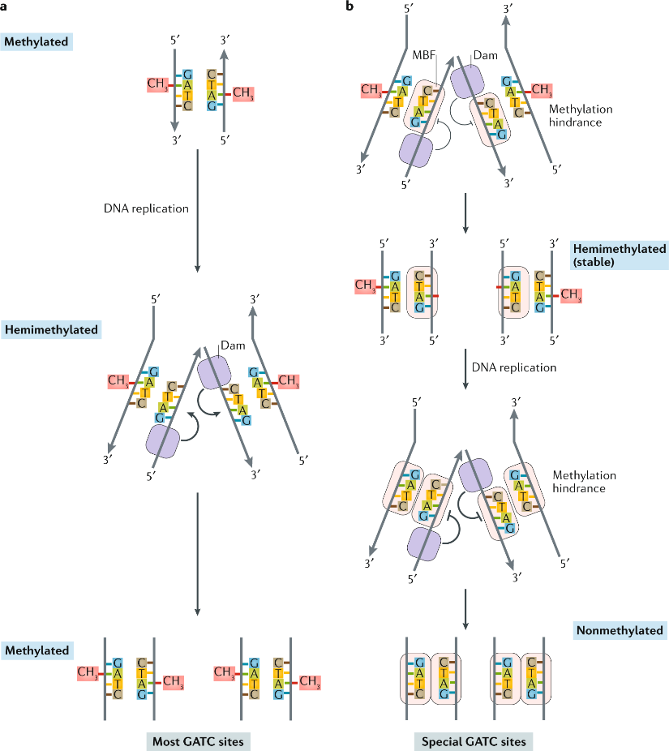
DNA methylation can occur on various motifs throughout the DNA, but in bacterial epigenetic regulation the typical examples studied involve promoter regions associated with m6A (by conserved Dam in Enterobacteria) (Figure 3b) (Payelleville and Brillard 2021).
Figure2. Transference of methylation beyond DNA replication (Sánchez-Romero and Casadesús 2020). Methylation-blocking factor (MBF)
In gammaproteobacteria, Dam methylase is synthesized throughout all stages of growth, and the hemimethylated GATC sites are brief since Dam trails the replication fork closely, being base methylation post-replicative (Sánchez-Romero and Casadesús 2020). Given the rapid occurrence of remethylation of Dam sites during chromosome replication, it is improbable for it to function as a prevalent mechanism for transcriptional regulation (Adhikari and Curtis 2016)
Moreover, DNA-binding proteins can distinguish between methylated and hemimethylated states at their target sites. The methylation state can affect the interaction between the proteins and DNA, either directly through steric hindrance or by inducing changes in DNA topology, leading to epigenetic regulation (Payelleville and Brillard 2021). In some cases, the binding of specific proteins to certain sites can prevent DNA methyltransferase activity, resulting in passive loss of methylation on the daughter strand (Figure 2b). Transcription factors such as Lrp, OxyR, Fur, and HdfR are examples of proteins involved in the "passive" erasure of methyl groups (Figure 3b). In a nutshell, the binding pattern of factors is influenced by the methylation state, and in turn, the methylation pattern can influence protein binding (Sánchez-Romero and Casadesús 2020).
In gammaproteo-bacteria, Dam- dependent methylation patterns are found at the transcriptional control regions of bistable loci. For instance, the synthesis of pap pili in uropathogenic E. coli is controlled by phase variation, in this case utilizing Dam methylation in the regulatory mechanism, resulting in heterogeneous populations of bacteria with Pap pili (ON state) or without Pap pili (OFF state). The regulatory region of the pap operon contains six binding sites for leucine-responsive regulatory protein Lrp and two GATC sites (Adhikari and Curtis 2016).
DNA methylation plays a significant role in regulating gene expression, as evidenced by altered gene expression patterns in strains lacking or overproducing DNA methyltransferase. However, it is important to note that changes in gene expression may not always indicate direct transcriptional control, as indirect effects are possible. In some cases, post-transcriptional regulation by Dam-dependent methylation has been observed, suggesting that methylation may influence mRNA stability, translation, or other post-transcriptional events (Sánchez-Romero and Casadesús, 2020). However, the precise mechanism and the involvement of 5′GATC3′ sites on genomic DNA in these cases remain unclear (Gao et al., 2023).
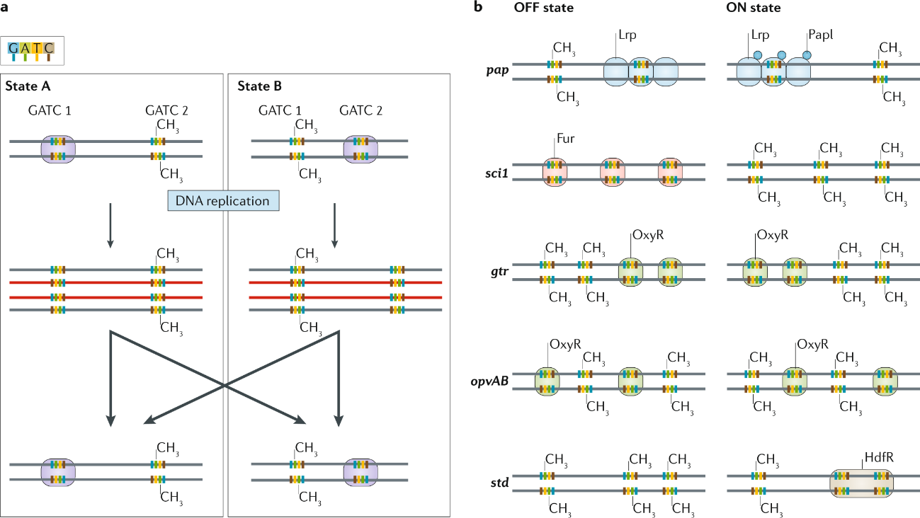
In a direct fashion, DNA methylation commonly leads to transcriptional repression, while demethylation, either single-stranded or double-stranded, often leads to transcriptional activation (Sánchez-Romero and Casadesús 2020). Nevertheless, other studies support that undermethylation of DNA, specifically in genes with GATC clusters within the coding sequence, can lead to a decrease in gene expression. This decrease is not dependent on DNA-binding proteins but is based on the physical principle that hemimethylated or unmethylated DNA has a higher melting point. Hénaut et al. (1996) proposed this hypothesis suggesting that undermethylation of GATC clusters at low temperatures blocks or decreases transcription of genes in E. coli. This mechanism allows E. coli to slow its growth and enter the stationary phase when transitioning from a high-temperature environment (the gut) to a low-temperature one (outside the gut). Notably, this hypothesis does not require the involvement of DNA-binding proteins for methylation-dependent gene expression regulation. Therefore, considering these premises and all the putative methylation motifs that a transcription unit can have on its gene body or on regulatory sequences around the prediction of methylation’s effect on a specific gene’s expression is beyond our capabilities.
Figure 3. a) Phase variation due to replication in an imaginary locus. b) specific loci examples (Sánchez-Romero and Casadesús 2020)
There is presence of conserved GATC clusters between species within the coding region of certain group of genes. As opposed to targeting global gene expression, it implies specific functional roles such as acid or nucleotide metabolism (Adhikari and Curtis, 2016). Brilli’s assignment
Kahramanoglou et al., (2012) evidenced from a cytosine methylation-deficient mutant that this modification in E. coli regulates gene expression during the stationary phase, proved by increased expression of the stress response sigma factor RpoS and its targets.
The contribution of nucleoid associated proteins, such as H-NS, in epigenetic mechanisms involving DNA-methylation has also been reported in various cases and therefore also contribute to the formation of bacterial subpopulations (Payelleville and Brillard 2021)

Phenotypic heterogenity (green)
Bacteria may respond to changes in their environment, such as nutrient availability or stressors, by switching between different phenotypic states as execution of their inherent regulatory programs. This behaviour is named responsive switching if all the cells in the homogeneous population respond in the same way and it happens thanks to what Simons (2011) called phenotypic plasticity, which is an adaptative trait for which phenotype-fitness association is predictable across environments. While subpopulation formation can be viewed as this, it frequently relies on stochastic events, either responding to environmental cues (responsive diversification) or merely stochastic in absence of environment fluctuations (stochastic switching) (Grimbergen et al. 2015). For example, random fluctuations in gene expression coming from factors affinity on DNA which, in turn, affects the methylation state. This is often referred to as "noise," can generate signals that propagate via feedback loops, both positive and negative, and facilitate the establishment of epigenetic lineages. These stochastic processes contribute to the emergence of diverse phenotypic states within bacterial populations, allowing for increased adaptability and survival in varying environmental conditions (Casadesús and Low 2013). The phenomenon of phenotypic heterogeneity in several major prokaryote pathogens plays a crucial role in the success of their infections (Payelleville and Brillard 2021).
Another phenomenon that causes phenotypic heterogeneity is adaptative tracking. It is the most studied mode of evolutionary response. The genetic variance and mutational rate create subpopulations that are subjected to fitness selection by the environment preassure. Optimal trait values and associated allele frequency variate constantly and natural selection continuously eliminates suboptimal forms that were previously well adapted (Simons 2011). This type of heterogeneity is however is not centred around isogenic organisms thus it is not within the scope of this thesis aim.
In E. coli, certain loci controlled by Dam-dependent methylation exhibit bistability, meaning they can switch between alternative states (ON/OFF) in a reversible manner controlling gene expression (Figure 3a). This phenomenon, known as phase variation, generates phenotypic cell variants (Sánchez-Romero and Casadesús, 2020).
There are several phase variation mechanisms in bacteria, such as those involving slipped-strand mispairing, site-specific re- combination or DNAmethylation. The first two mechanisms require chang- ing DNA sequence, while methylation is sequence independent and therefore a form of epigenetic regulation (Adhikari and Curtis 2016)
The frequency of switching is influenced by the affinity of DNA-binding proteins for their binding sites and requires DNA replication (Sánchez-Romero and Casadesús, 2020). The binding events after DNA replication determines, at each locus, the subsequent gene expression of the emerging cell, leading to divergence and the emergence of distinct phenotypes. This phenomenon scaled to the whole genome may give rise to a great phenotypic heterogeneity driven by methylation. This can occur as part of a developmental program, such as sporulation, where different genetic expression patterns guide cell differentiation. Additionally, due to stochastic binding, it can result in the bifurcation of an isogenic population into two reversible metabolic states, creating bistability (Casadesús and Low 2013).

- Bet-hedging (blue)
Bet-hedging is a survival strategy where organisms develop different maladapted phenotypes within clonal populations to increase long-term fitness in unpredictable environments. It involves spreading risks and optimizing population fitness by minimizing fitness variance over time and maximizing geometric mean fitness across fluctuating conditions. Bet-hedging is a case example of microbial phenotypic heterogeneity in which many subpopulations having slightly different/intermediate metabolic states which would be specialized in different environments regardless of the current conditions so as to be ready at population level to endure sudden changes. Bacillus sporulation is an example where not all forms of phenotypic diversification lead to the development of intermediate phenotypes. This phenomenon can arise from responsive diversification or from stochastic switching. This strategy differs from developing an intermediate phenotype that is moderately fit in all conditions but never a specialist (Grimbergen et al. 2015).
Depending on the robustness of regulatory circuits in bacteria, they can trigger a response in consequence of environmental cues or lead to stochastic switch triggered by noise. The robustness of a regulatory pathway comes with high costs of maintenance. The environmental variability and its frequency determine the balance between costs and benefits of responsive switching versus maladaptation stochastic phenotype and consequently the evolution of the system is bound to become more or less robust. In situations where environmental fluctuations are rare, stochastic switching is an advantage compared to responsive switching (Grimbergen et al. 2015).
Simons (2011) introduced categories of evidence to assess whether observed phenotypic heterogeneity qualifies as a bet-hedging strategy. The highest category, category VI, requires studies to demonstrate two features: a) the bet-hedging trait increases fitness compared to a non-bet-hedging alternative in a fluctuating environment and b) the phenotype switching rate (heterogeneity level) should correlate with the frequency of environmental fluctuating selection, which shows to be an adaptative trait. Currently, no study on microbial phenotypic heterogeneity has provided category VI evidence, indicating that true bet-hedging by microorganisms has not been convincingly observed yet (Simons 2011).
Bacillus subtilis sporulation is a survival response to starvation, where highly resistant endospores are formed at the cost of reduced reproductive offspring. This phenotype switching is driven by a bistable regulatory network that incorporates environmental information and stochastic switching through regulatory noise. Stochastic initiation of sporulation ensures survival in case responsive sporulation is too slow or the environment is abruptly harmful. This complexity highlights the challenge of studying bet-hedging in microbial systems, where both responsive and stochastic switching can coexist to form spores due to a not-so-robust sensory system. When environments provide partially reliable signals about future events, it is predicted that a stable evolutionary strategy would involve a combination of deterministic and stochastic switching strategies (Grimbergen et al. 2015).
The ability to switch between the persister and normal phenotype is a form of bet-hedging (Grimbergen et al. 2015)
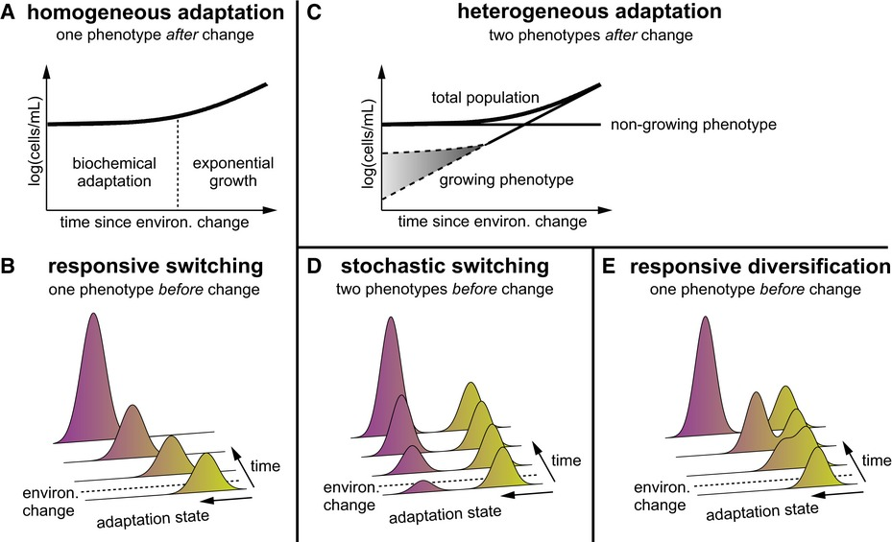
Bet-hedging may be an important strategy in carbon metabolism. When bacteria are introduced to a new environment, there is an initial lag phase before they adapt and start growing on the new carbon source. Traditionally, this lag phase was thought to be due to individual cells undergoing biochemical adaptations uniformly (Figure 4a,b). However, an alternative hypothesis suggests that the lag phase upon shifting media on an isogenic population is caused by the emergence of two phenotypes: a minority growing and a main non-growing. This subpopulation can arise from the homogeneous isogenic population through either stochastic switching before the environmental change (Figure 4c,d) or responsive diversification as consequence of the new conditions (Figure 4c,e). It was demonstrated thought 13C-labeled acetate that after glucose-gluconeogenic substrate (acetate) shifts in E. coli responsive diversification occurs. Non-growing cells enter a dormant state but remain viable after the carbon source shift. Spontaneous suppressor mutations were discarded as the cause of diversification, as repeating the experiment with cells from the growing subpopulation still resulted in two distinct phenotypes amounting an identical growing population ratio (Kotte et al., 2014).
Figure 4. (Kotte et al. 2014)
In the same study, they observed that the presence of acetate before the shift did not prepare the cells for later acetate consumption. However, the concentration of extracellular acetate after the shift had a significant positive impact on both the growth rate and the fraction of adapting cells, α, and suggested a connection between extracellular acetate levels, substrate uptake rate, and central metabolism. To verify this, they did glucose-fumarate shift, which—opposed to acetate—is actively transported. By increasing the expression of the fumarate transporter, they were able to rise α (Kotte et al. 2014).
Carbon catabolite repression (CCR) is responsible for suppressing metabolic pathways related to non-preferred carbon sources. During metabolic shifts, there are instances where certain cells fail to respond promptly, leading to responsive diversification. In the case of glucose-cellobiose diauxie in Lactococcus lactis, two distinct populations arise: one capable of metabolizing cellobiose (Cel+) and one unable to do so (Cel-). It is speculated that the non-growing Cel- subpopulation was in allow energetic state during the shift and induced the stringent response in order to be maintained to facilitate future utilization of alternative carbon sources, as it was seen with a latter shift to galactose. Recent research suggests that the level of heterogeneity in catabolite repression can undergo evolutionary changes, resulting in the emergence of "generalist" or "specialist" cells. These findings underscore the adaptability and evolvability of response infidelity in microbial systems (Solopova et al. 2014) .
Figure 5. (Solopova et al. 2014)
Researchers found that cells precultured with cellobiose exhibited a shorter lag phase during the transition from glucose to cellobiose medium compared to cells precultured with glucose. This suggests the involvement of an epigenetic mechanism in the metabolic switching process. Furthermore, epigenetic memory has been observed in the expression of the lac operon in Escherichia coli, where the memory effect lasted for two cell generations (Solopova et al., 2014) (Robert et al. 2010).
- Epigenetic regulation networks
coupling of transcriptome analysis with extensive methylome analysis. It may lead to the identification of putative epigenetic regulation networks combined methylome/transcriptome strategy
has been rarely employed. When two subpopulations are present, each one displaying a particular DNA-methylation pattern and a particular transcription pattern. Classical tools (e.g., WGBS, SMRT sequencing and RNA-seq analysis) allow the detection of the bulk. To distinguish the two subpopulations, single cell tools need to be applied (e.g., SMALR for DNA methylation and Record-seq or PETRI-seq for transcription). this combined methylome/transcriptome strategy has been rarely employed (Payelleville and Brillard 2021).

Genome scale metabolic modelling (red)
“A GEM computationally describes a whole set of stoichiometry-based, mass-balanced metabolic reactions in an organism using gene-protein-reaction (GPR) associations that are formulated on the basis of genome annotation data and experimentally obtained information” (Gu et al. 2019).
the GEM allows the prediction of metabolic flux values for an entire set of metabolic reactions using optimization techniques, such as flux balance analysis (FBA), which uses linear programming. GEM also serves as a platform for the integration and analysis of various types of data such as omics and kinetic data. (Gu et al. 2019).
Relevant applications that have benefited from advances in the use of GEMs include strain development for the production of bio-based chemicals and materials, drug tar- geting in pathogens, the prediction of enzyme functions, pan-reactome analysis, modeling interactions among mul- tiple cells or organisms, and understanding human diseases. (Gu et al. 2019).
GEMs provide a framework for mapping species-specific knowledge and complex ‘omics data to meta- bolic networks, but coupled with constraint-based reconstruction and analysis (COBRA) methods, such as Flux Balance Analysis (FBA), they facilitate the translation of hypotheses into algorithms that can be used to generate testable predictions of metabolic phenotypes (Bernstein et al. 2021)
Metabolic engineering can be defined as purposeful modification of metabolic and cellular networks by employing various experimental techniques to achieve desired goals. What distinguishes metabolic engineering from genetic engineering and old-fashioned strain improvement before the emergence of recombinant DNA technique is that it considers metabolic and other cellular network as a whole to identify targets to be engineered or studied. To describe the cellular phenotype concentrations of proteins and metabolites have inherent limitations. Metabolic fluxes represent the reaction rates in metabolic pathways, and serve to integrate these factors through a mathematical framework. Metabolic flux analysis (MFA) is an analytical technique that quantifies intracellular metabolic fluxes.
MFA is based on mass balances around intracellular metabolites under the pseudo-steady state assumption, and two methods have generally been used: 13C-based flux analysis and constraints-based flux analysis. Constraints-based flux analysis is a way of GEM construction for the optimization simulation thought different algorithms. First of all, stoichiometric model is reconstructed based on genomic information and literature. The stoichiometric model represents all the genes/enzymes, reactions and metabolites and their in vivo relationship; it is the validated network which can successfully describe all the possible metabolic phenotypes (i.e. combination of metabolic fluxes) through a solution spaces. The solution space of metabolic fluxes, which represents all physiologically plausible states, is further reduced by employing additional constraints so as to make the simulation results become more realistic.
- The first method is the addition of regulatory constraints (Fig. 3(D)). The metabolic network can be combined with a transcriptional regulatory network, in which biological correlations among gene, proteins and reactions are described by Boolean logics AND, OR and NOT. genes in the transcriptional regulatory network are appropriately assigned with binary values under specific conditions. The flux can be set to zero if its corresponding gene is inactive (= 0), thereby.
- Another method is to constrain the solution space by employing experiments-based metabolic flux data. The 13C-based metabolic fluxes can serve as realistic constraints to reduce the solution space of constraints-based genome-scale flux ana-lysis.
It is then simulated by linear optimization technique using an appropriate objective function (e.g. maximization of cell growth rate) and constraints that restrict the solution space within cell’s capacity. enables systematically predicting and evaluating the effects of genetic and/or environmental perturbations on the cell on a global scale.
optimal results obtained by using the objective function during the constraints-based flux analysis may be different from real cellular metabolism (i.e., the cellular metabolism may operate in a suboptimal mode).
(Kim et al. 2008)

METHODS
- NGS technologies methylation detection and processing
Three main methods are currently used for the base-resolution sequencing of DNA methylation. The Whole Genome Bisulfite Sequencing (WGBS). After sequencing (usually short-read Illumina sequencing) and alignment, m5C can then be identified. Another one is SMRT sequencing, a delay in polymerization is generated during the recording of the DNA sequence (InterPulse Duration or IPD). While it can easily detect m4C and m6A, this technology has strong limitations to detect m5C. Finally, the Oxford Nanopore technology (ONT), was shown to efficiently detect modified bases m5C and m6A. (Payelleville and Brillard 2021)
- Whole genome bisulfite sequencing (WGBS), Anchor-Based Bisulfite Sequencing (ABBS) as described in the work of (Chapin et al. 2022). Dataset form SRA SRP329794, E.coli K12 substr. MG1655 samples used:
- SRR15242564: clone 1, WGBS primers (NNNNNN)
- SRR15242565: clone 1, ABBS primers (NNNNNSuperG)
- SRR15242568: clone 2, WGBS primers (NNNNNN)
- SRR15242569: clone 2, ABBS primers (NNNNNSuperG)
Reference genome: NC_000913.3 Mapping and 5mC methylation call was done with Bismark utility, v0.24.0 (https://github.com/FelixKrueger/Bismark). From the CX_report the selection criteria for cytosine positions was a percentaje of methylation between 25 and 75, both included, and a coverage equal or above 25 found in all sample preparations. The intersection analysis was performed with bedtools (v2.30.0) intersect (https://bedtools.readthedocs.io/en/latest/) . Moreover samtools 1.6 (https://github.com/samtools/samtools) were used. See the commands employed at commands.txt. All the hits were found in a CHG context.
- PacBio
- Raw dataset from: PacificBiosciences / DevNet 8 plex Ecoli Multiplexed Microbial Assembly. (ccano/DevNet n.d.) Reference genome: NC_000913.3. Processed with: SMRT Link v11.0. Indexes: 0,4,6 and 7.
- Processed dataset: gff file MethSMRT (Sun Yat-sen University 2016) from the raw data SRS674093 (Berlin K n.d.)
The methylation call (m6A, m5C, m4C) were filtered by IPDRatio>= 4 & fraction methylation between 25-75% to generate an out.gff
- Gene association and functional enrichment
library(GenomicFeatures)
Gene annotation employed (https://www.ncbi.nlm.nih.gov/assembly/GCF_000005845.2/).
conv_38DC2E424FE51674044440701.txt converted genes with DAVID from locus tag annotation to gene_symbol
Functional annotation (Bioconductor: org.EcK12.eg.db package).
Functional enrichment (Bioconductor: clusterProfiler package).
RegulonDB annotation of operons: cds and regulatory positions, genes in the operon
Criteria: 1 or more methylation overlapping with operon annotation with regulatory region or 4 or more methylations overlapping with the cds. Whitout strandedness.
Enrichment on GO terms and on KEGG pathways.
- Motif identification
- Motif identification with multiMotifMaker. (https://github.com/bioinfomaticsCSU/MultiMotifMaker): java -jar ./artifacts/MultiMotifMaker.jar find
- Extension of each position in the bed files up to the lenght of each of the identified motifs and extract the corresponding fasta sequence (mEpigram bedToFasta.py) so that the motif would fit the sequence exactly.
- Repeat step 2 for the filtered bed (partial methylation 25% - 75%) and for the full bed files (>25% methylation)
- RSAT prokaryotes parameters: search strand (direct only), substitutions (1), other: default
- Comparison of motif degeneracy score in full vs filtered (methylation_motifs.R)
No significant degeneracy of motifs that are partially methylated vs all the methylation set.
- Metabolic model
The genome-wide metabolic model used was iM1515 (http://bigg.ucsd.edu/models/iML1515) from Escherichia coli str. K-12 substr. MG1655 (Monk et al. 2017b). iML1515 accounts for 1,515 open reading frames and 2,719 metabolic reactions involving 1,192 unique metabolites. iML1515 has been validated and customized for use in different growth conditions and is the most comprehensive E. coli reconstruction to date. In iML1515’s computational format, constraint-based methods can be used (i.e., the COBRA Toolbox24) to assess network properties. (Documentation for COBRApy — cobra 0.26.3 documentation n.d.)
The most recent version, iML1515, contains information on 1515 open reading frames, twice the number of open reading frames incorporated in the original iJE660 model. The iML1515 model shows 93.4% accuracy for gene essentiality simulation under minimal media containing 16 different carbon sources (Gu et al. 2019)
COBRApy package in Python for constraint-based metabolic modelling.
Baseline maps merged with escher_map_merger (https://github.com/reimopriidik/escher_map_tools): Central_metabolism, Fatty_acid_biosynthesis_(saturated) in Escher.
Reaction ATPS4rpp, the reaction has 9 genes (3 non essential). Essential genes for growth on glycerol minimal medium: atpA (b3734) atpB (b3738) atpC (b3731) atpF (b3736) atpG (b3733) atpH (b3735). They were not predicted to be essential by the model and were not associated with essential reactions, but Ecoli is not growing in its absence (Joyce et al. 2006)

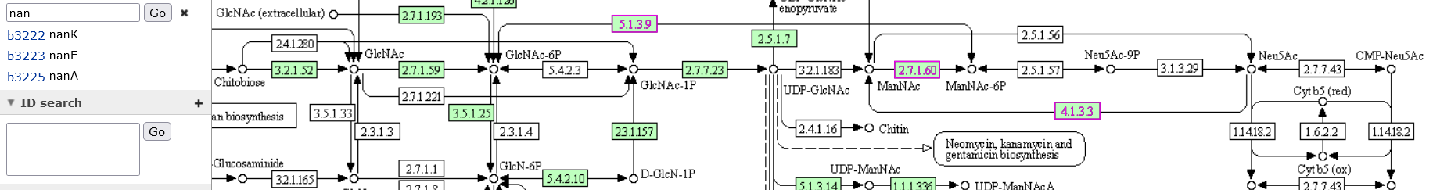

DauA is an inner membrane protein that transports C4 dicarboxylates in an aerobic, acidic (pH 5) environment. DauA transports the monoanion and dianion form of succinate and fumarate, and the dicarboxylic amino acid aspartate. At pH 5, DauA is the main succinate transporter and DctA, which is active for dicarboxylate transport at pH 7, is not produced [Karinou13]. DauA consistently co-purifies with proteins involved in fatty acid metabolism - FabA, FabR, FadE and FadJ [Babu10].
E. coli ΔccmA-H mutant strain (EC06) is not able to produce mature c-type cytochromes under anaerobic, nonfermentative growth conditions [ThonyMeyer95]
When E. coli is growing in glucose minimal medium, nanA expression is barely detectable due to inactivation of CRP and repression by NanR (4, 7). However, with CRP activated during growth on a non-catabolite-repressing substrate like glycerol, nanA expression increases, presumably by RNA polymerase blocking repressor binding (14
- Experimental correlation of data (transcriptomics data)
To validate iML1515 we carried out experimental genome-wide gene-knockout screens for the entire KEIO collection (3,892 gene knockouts)16 grown on 16 different carbon sources that represent different substrate entry points into central carbon metabolism (Fig. 2a, Supplementary Fig. 9 and Supplementary Data sets 10 and 11) (Monk et al. 2017a).
Our focus was on a lab strain of E. coli (BW25113), a representative K-12 strain (Tong et al. 2020)
- Computation Of Microbial Ecosystems in Time and Space (COMETS)
Genome-scale metabolic modeling and flux balance methods can be applied to microbial communities, considering their interactions and impact on the environment; and even predicting emergent features. To simulate multiple microbial species in complex and spatially structured environments COMETS software uses dynamic flux balance analysis (dFBA); i.e., it considers steady-state metabolism within cells but treats species abundance and environmental metabolites as dynamic variables. (Dukovski et al. 2021)
dFBA estimates resource uptake is based on environmental concentration using a Michaelis–Menten equation; assuming steady-state intracellular metabolites and dynamic extracellular metabolites. This predicts metabolic fluxes and interactions considering changing resource availability. (Dukovski et al. 2021)
Using COMETS we can simulate an heterogeneous clonal population to see the growth capabilities with respect change in environmental conditions in contrast to an homogeneous wild type population. Some candidate genes and associated reactions selected from the modelling in M9 are to be down or upregulated to create new models set in coculture with the wt model in order to simulate this phenotypic heterogeneity.
RESULTS
Loss of ATP hydrolysis activity by CcmAB results in loss of c-type cytochrome synthesis and incomplete processing of CcmE (Christensen et al. 2007). NapB: periplasmic nitrate reductase cytochrome c550 protein (RegulonDB n.d.)
PHEMEabcpp GPR: b2198 and b2199 and b2197 and b2200 and b2201= ccmA,ccmB,ccmC,ccmD,ccmE (ccmF,G and H are not metabolic genes)

It is conceivable that a methyltransferase that is involved in phase variation can cause even more variation possibilities once the methyltransferase itself goes through a phase variation (Gao et al. 2023)
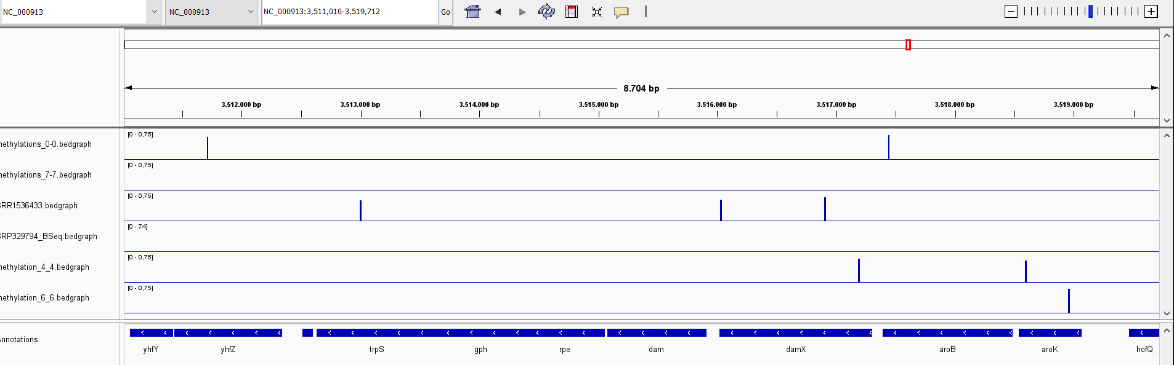

BIBLIOGRAPHY
Berlin K, Koren S, Chin CS, Drake JP, Landolin JM, Phillippy AM. “Pacific Biosciences Model Organism Genome Sequencing-Ecoli_K12_P4C2 (SRR1536433).” Assembling large genomes with single-molecule sequencing and locality-sensitive hashing. Nat Biotechnol. 2015 Jun;33(6):623-30. doi: 10.1038/nbt.3238. Epub 2015 May 25. Erratum in: Nat Biotechnol. 2015 Oct;33(10):1109. PMID: 26006009.
Casadesús, Josep, and David A. Low. 2013. “Programmed Heterogeneity: Epigenetic Mechanisms in Bacteria.” Journal of Biological Chemistry 288(20): 13929–35.
ccano/DevNet. “Https://Github.Com/PacificBiosciences/DevNet/Wiki/8-Plex-Ecoli-Multiplexed-Microbial-Assembly.”
Chapin, Nathaniel, Joseph Fernandez, Jason Poole, and Benjamin Delatte. 2022. “Anchor-Based Bisulfite Sequencing Determines Genome-Wide DNA Methylation.” Communications Biology 5(1): 1–6.
Grimbergen, Ard Jan, Jeroen Siebring, Ana Solopova, and Oscar P Kuipers. 2015. “Microbial Bet-Hedging: The Power of Being Different.” Current Opinion in Microbiology 25: 67–72.
Monk, Jonathan M. et al. 2017. “IML1515, a Knowledgebase That Computes Escherichia Coli Traits.” Nature biotechnology 35(10): 904–8. https://pubmed.ncbi.nlm.nih.gov/29020004/ (January 12, 2023).
Sun Yat-sen University. 2016. “MethSMRT-BROWSE.” Laboratory of Bioinformatics and Gene Regulation. http://sysbio.gzzoc.com/methsmrt/browse.html?Prokaryota (February 27, 2023).
Adhikari, Satish, and Patrick D Curtis. 2016. “DNA Methyltransferases and Epigenetic Regulation in Bacteria.” FEMS Microbiology Reviews 023: 575–91. https://academic.oup.com/femsre/article/40/5/575/2198251.
Grimbergen, Ard Jan, Jeroen Siebring, Ana Solopova, and Oscar P Kuipers. 2015. “Microbial Bet-Hedging: The Power of Being Different.” Current Opinion in Microbiology 25: 67–72.
Kahramanoglou, Christina et al. 2012. “Genomics of DnA Cytosine Methylation in Escherichia Coli Reveals Its Role in Stationary Phase Transcription.” Nature Communications. http://tools.neb.com/~vincze/cutfreq/CCWGG.html.
Roberts, Dr. Richard J., and and Dana Macelis. “REBASE.” http://rebase.neb.com/rebase/rebase.html (April 17, 2023).
“Documentation for COBRApy — Cobra 0.26.3 Documentation.” https://cobrapy.readthedocs.io/en/latest/ (April 17, 2023).
Gao, Qun et al. 2023. “Bacterial DNA Methyltransferase: A Key to the Epigenetic World with Lessons Learned from Proteobacteria.”
Tong, Madeline et al. 2020. “Gene Dispensability in Escherichia Coli Grown in Thirty Different Carbon Environments.” https://doi.org/10.1128/mBio.02259.
Dukovski, Ilija et al. 2021. “A Metabolic Modeling Platform for the Computation of Microbial Ecosystems in Time and Space (COMETS).” Nature Protocols 16(11): 5030–82.
Roberts, Dr. Richard J., and and Dana Macelis. “REBASE.” http://rebase.neb.com/rebase/rebase.html (April 17, 2023).
Adhikari, Satish, and Patrick D Curtis. 2016. “DNA Methyltransferases and Epigenetic Regulation in Bacteria.” FEMS Microbiology Reviews 023: 575–91. https://academic.oup.com/femsre/article/40/5/575/2198251.
Grimbergen, Ard Jan, Jeroen Siebring, Ana Solopova, and Oscar P Kuipers. 2015. “Microbial Bet-Hedging: The Power of Being Different.” Current Opinion in Microbiology 25: 67–72.
Gu, Changdai et al. 2019. “Current Status and Applications of Genome-Scale Metabolic Models.” Genome Biology 2019 20:1 20(1): 1–18. https://genomebiology.biomedcentral.com/articles/10.1186/s13059-019-1730-3 (December 28, 2022).
Kim, Hyun Uk et al. 2008. “Metabolic Flux Analysis and Metabolic Engineering of Microorganisms.” This journal is ß The Royal Society of Chemistry 4. www.rsc.org/molecularbiosystems.
Kotte, Oliver, Benjamin Volkmer, Jakub L Radzikowski, and Matthias Heinemann. 2014. “Phenotypic Bistability in Escherichia Coli ’s Central Carbon Metabolism.” Molecular Systems Biology 10(7).
Oliveira, Pedro H., and Gang Fang. 2021. “Conserved DNA Methyltransferases: A Window into Fundamental Mechanisms of Epigenetic Regulation in Bacteria.” Trends in Microbiology 29(1): 28–40.
Payelleville, Amaury, and Julien Brillard. 2021. “Novel Identification of Bacterial Epigenetic Regulations Would Benefit From a Better Exploitation of Methylomic Data.” Frontiers in Microbiology 12.
Robert, Lydia et al. 2010. “Pre-Dispositions and Epigenetic Inheritance in the Escherichia Coli Lactose Operon Bistable Switch.” Molecular Systems Biology 6: 357. /pmc/articles/PMC2872608/ (May 31, 2023).
Sánchez-Romero, María A., and Josep Casadesús. 2020. “The Bacterial Epigenome.” Nature Reviews Microbiology 18(1): 7–20.
Simons, Andrew M. 2011. “Modes of Response to Environmental Change and the Elusive Empirical Evidence for Bet Hedging.” Proceedings of the Royal Society B: Biological Sciences 278(1712): 1601–9.
Solopova, Ana et al. 2014. “Bet-Hedging during Bacterial Diauxic Shift.” Proceedings of the National Academy of Sciences of the United States of America 111(20): 7427–32. www.pnas.org/cgi/doi/10.1073/pnas.1320063111 (May 30, 2023).
Kotte, Oliver, Benjamin Volkmer, Jakub L Radzikowski, and Matthias Heinemann. 2014. “Phenotypic Bistability in Escherichia Coli ’s Central Carbon Metabolism.” Molecular Systems Biology 10(7).

